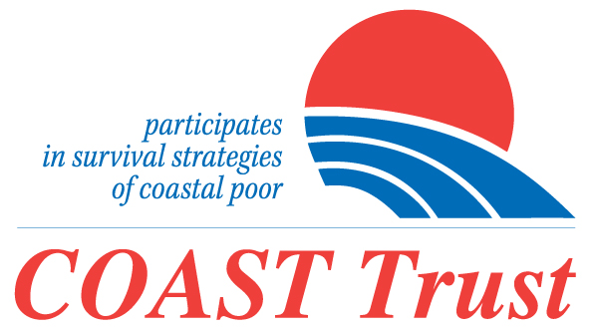
Press release
Participation of the local CSOs and the Union Parishad is must in the Rohingya Responses
A Joint Risk Assessment is Necessary to Assess Host Communities’ Risks:
Integrated Development Plan with Priority in Education is Needed For Cox’s Bazar

Cox's Bazar, 19 December 2019. Different agencies are scrutinizing the problems, needs, and risks of the host communities in different ways, so the people of Cox's Bazar affected due to the Rohingya influx are not getting the benefit of development programs equitably. Therefore, first of all, a joint risk assessment must be conducted with the participation of all stakeholders. An effective and holistic development plan should be taken based on that risk assessment. Education should be given top priority in the development plan and the participation of local CSOs and local Union Parishads (UP) at all levels should be ensured. The speakers opined these during a discussion meeting held at Cox's Bazar today. COAST Trust and UNHCR hosted the discussion titled 'Together for Better Rohingya Response Until the Repatriation and Facilitating Development in Cox's Bazar'.

Rezaul Karim Chowdhury of COAST Trust and Abu Musrhed Chowdhury of Cox's Bazar CSO NGO Forum moderated the discussion. KM Abdus Salam, Director General of the NGO Affairs Bureau was present as the chief guest of that event. Among others Barrister Manzoor Hasan of Center for Peace and Justice, BRAC University, Ms. Shireen Hauqe of Naripokkha, Disaster Management Expert Mr. Abdul Latif Khan, Disaster Management Expert and columnist Nayeem Gowhar Warha, Cox's Bazar chief at IOM, Manuel Manoise Periera, Hinako Talki, Senior Operations Manager of UNHCR, Camp In-charge Abu Zafar Oabidullah and Assistant Commissioner of District Commissioner Office Jinnat Shahid Pinky were present. Upazila chairmen and vice-chairmen from different Upazilas, chairmen of different Union Parishads, teachers, students, journalists, civil society representatives also spoke at the function. Representatives of national and international NGOs and UN agencies, 6 Camps In charges also participated in the charge of six camps.

Organizers informed that, COAST formed 4 Social Cohesion Committees in 4 unions in Ukhiya and Teknaf with the participation of local union council members, teachers, civil society. Members of the committees visited the camps and local areas to identify the sufferings and problems of the Rohingya and the local people. Md. Mujibul Haque Munir of COAST Trust presented some specific recommendations on behalf of the committees, some recommendations are to spend 25% of the relief funds for the local people, to engage the Rohingya youth in various activities, especially with education, to make the Rohingya women and girls especially aware of trafficking, reduce the use of cars in the Rohingya camps and special initiatives for local educational institutions.

Samira Akhter, a student at Ukhia College, said that many students leave college for the job, due to poor attendance there is no proper class. Due to the high cost of travel to college due to the pressure of passengers, it is now difficult to go to college regularly. Noor Mohammad Shikdar of Voice of Ukhia said that, many plans have been taken for the last 26 months, and now the need for local people will be to ensure those plans with their participation. Abu Murshed Chowdhury said, college students, even students of class eight are now involving with jobs, teachers are leaving school-college for joining NGOs-INGOs to get higher salaries. Thus, there is a risk of the generation gap in terms of education in Cox’s Bazar.

Shirin Haque said, women and girls of both the communities are at risk of trafficking and violence. This should be especially considered in the development plan. Gowhar Naeem Wahra said, many students are working, considering this fact school-college timing can be revised. Abdul Latif Khan said, instead of identifying the risks or problems separately, a joint risk assessment is needed. The relief worker's residence and the offices of all agencies should be in the vicinity of the camp areas. Hinako Talki said UNHCR is implementing about 80 programs in the local areas, and many are working on infrastructure development. UNHCR is working to ensure the livelihood of 6,000 vulnerable women. Manuel Moniz Pereira said sustainable development in Ukhia-Teknaf requires a lot of investment. Rezaul Karim Chowdhury said, the Hon'ble Prime Minister has taken nine mega projects in Cox's Bazar including airport, state-of-the-art railway, large power plant and shelter project. In order to ensure that there should not be any obstacle in the mega projects of the Prime Minister, every effort must be made to keep Cox's Bazar free from terrorism.

KM Abdus Salam said the NGO Bureau is trying to ensure coordination in implementing programs for Rohingya and local people. We should consider that a portion of the funds are earmarked for the local area and it is also important to ensure transparency in the activities of the NGOs.

Report by: Rezaul Karim Chowdhury (017 1152‬‬‬ 9792), Jahangir Alam (01713328827)

